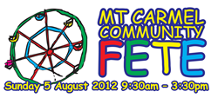
Come and experience the excitement of the Mt Carmel Community Fete on Sunday, 5 August from 9.30am until 3.30 pm at Norfolk St, Coorparoo. With over 30 stalls it will be a fun-filled day for the whole family. Don't miss our popular cake and sweets stalls, our pre-loved bargains, toddler chill-out zone and fun stalls for the kids. Grab lunch at one of our many food stalls; Modern Australian by Ashton and Old or our popular Greek Food stall; Yummilicious handmade Pizzas, Asian food or our delicious BBQ. With two live auctions, an Art Union and raffles drawn each half hour, there are close to $15,000 worth of prizes to be won all day. There will be nine awesome rides including the legendary Round-Up and the Cobra; barnyard babies and pony rides, as well as live entertainment and bands all day. Don't miss the Brisbane Lions players and the Bernie Gabba Gang, or Roary from the Brisbane Roar! For more information visit www.mtcarmelfete.com.au or become a Fete Facebook friend -Facebook.com/mtcarmelfete

